**FINAL PROJECT**

**Project Title**: - Airline Data Management and Analysis Using Power BI

**TASK 1: -** Data Preparation and Cleaning

● Extract and transform data in Power Query.

● Clean data: remove duplicates, handle missing values, and format columns.

● Deliverables: Screenshot of Power Query Editor showing cleaned data.

STEP 1): - Load all the 3 excel files to power query.

STEP 2): - Removed null columns which are not required in data from all three files.

STEP 3): - Now Data is clean and then Load the data to power BI desktop.

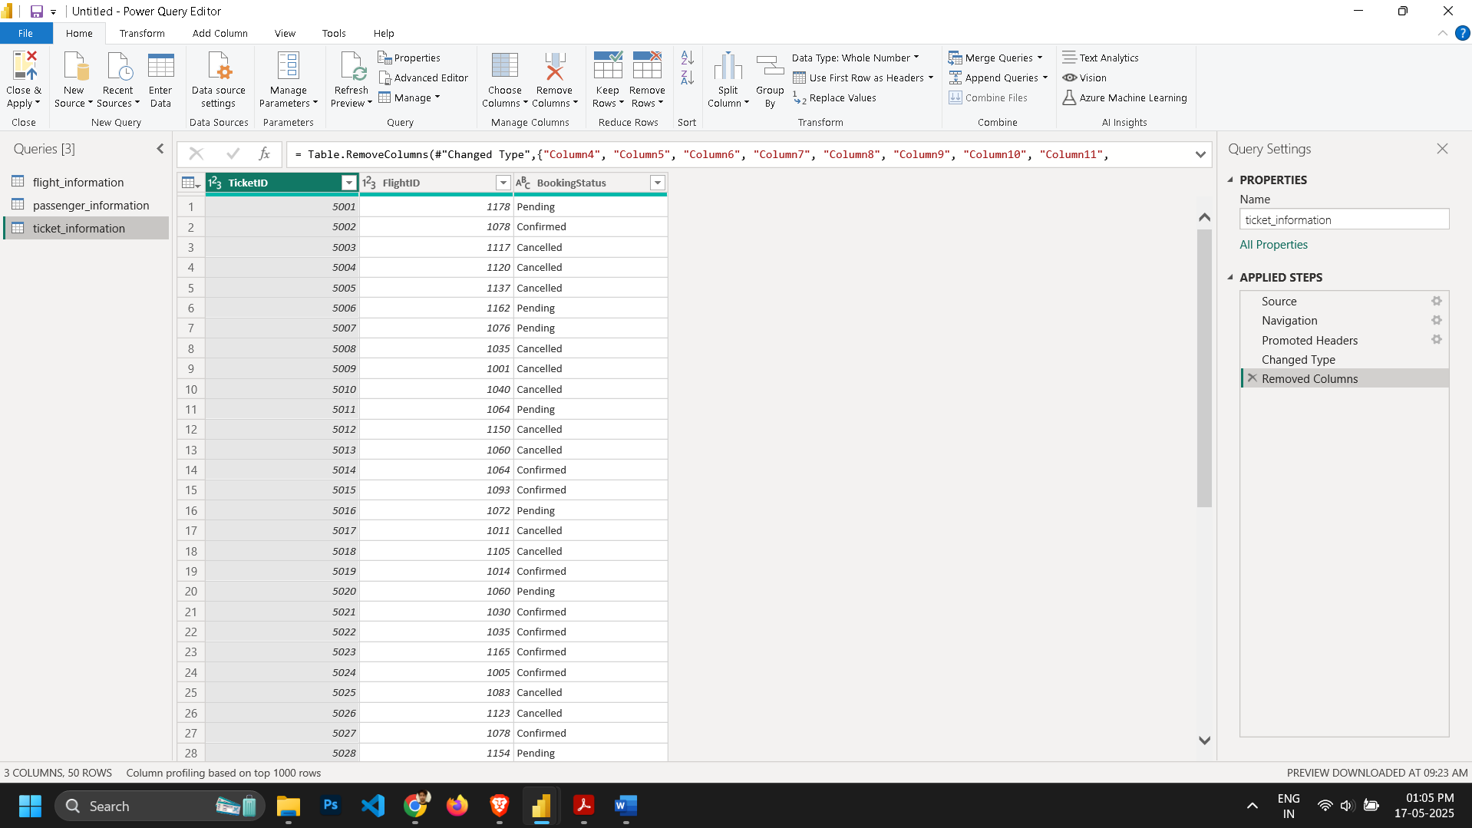

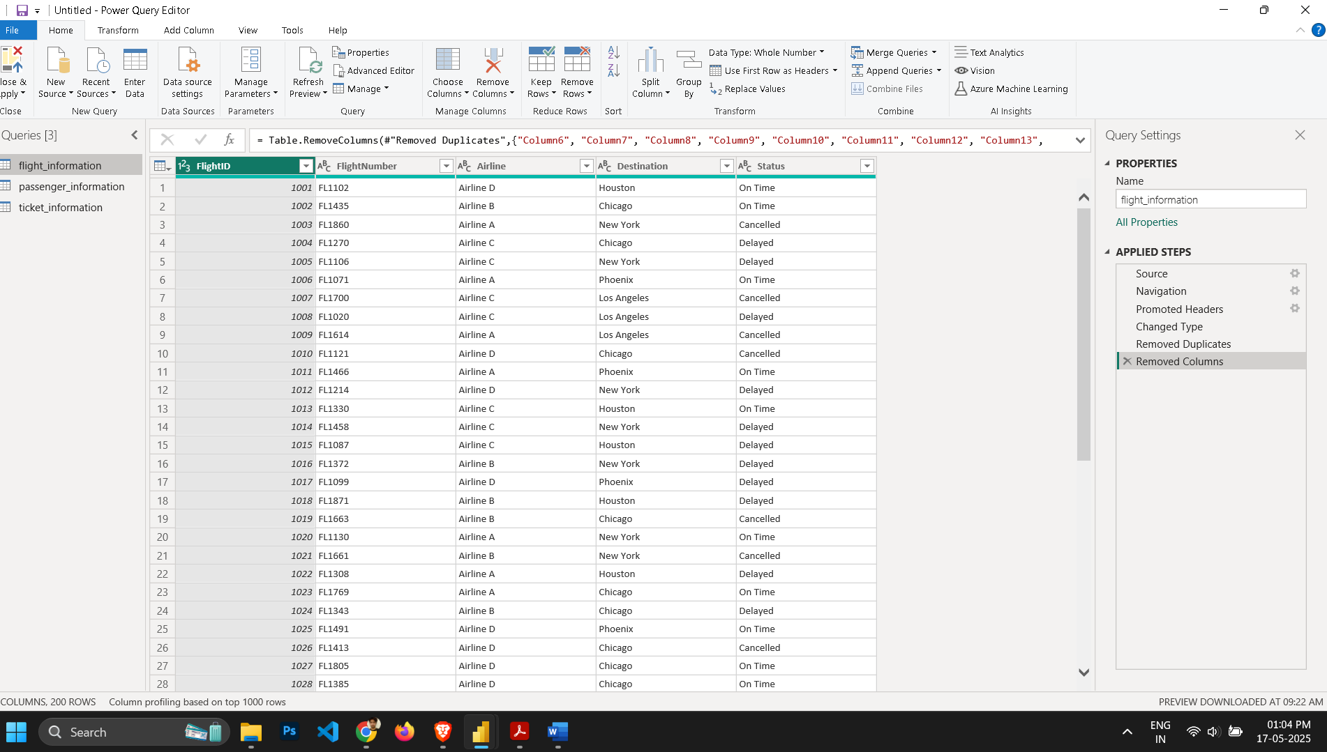

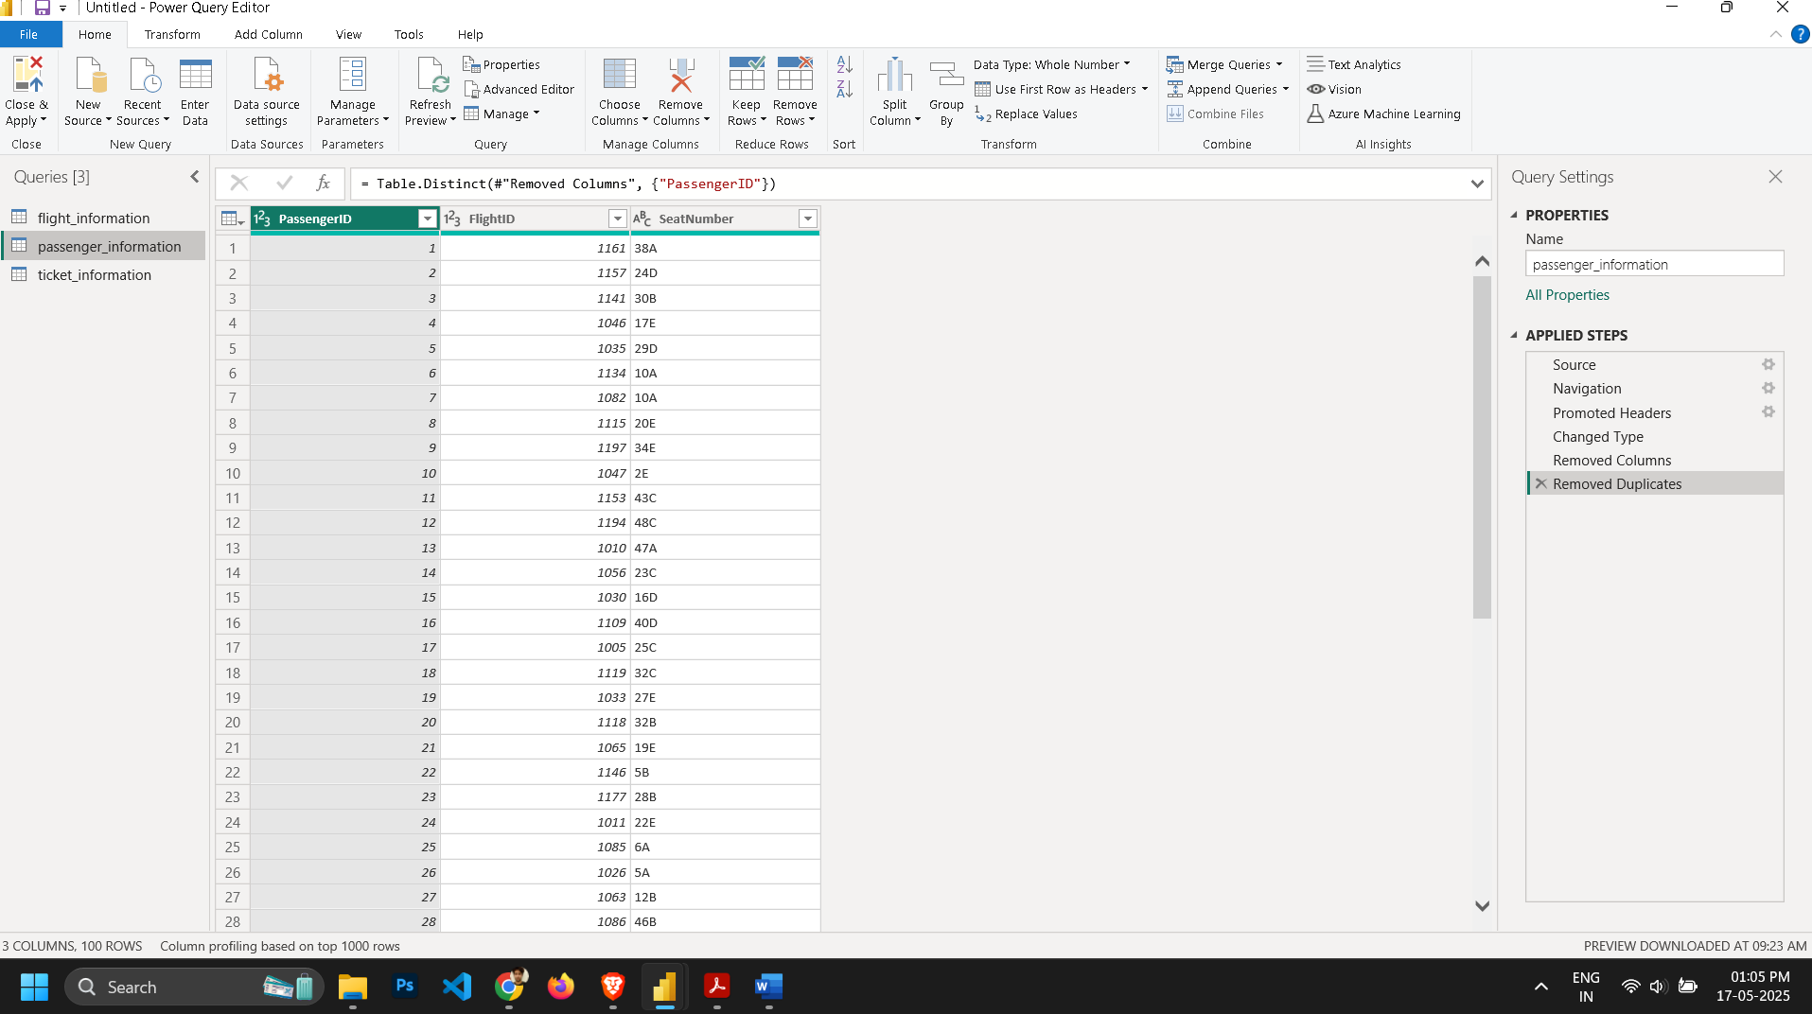

**Task 2: - Data Modelling**

● Create relationships between datasets (FlightID as the key).

● Understand cardinality and configure the model appropriately.

● Deliverables: Screenshot of the data model with relationships.

**STEP 1):-** go to model view connect flightId from ticket_information table to flightId of Flight_information table. This is many-to-one relationship.

**STEP 2):-** Then connect FlightId of Flight_informaion to Flight_id of Passenger_information. This is one-to-many relationship.

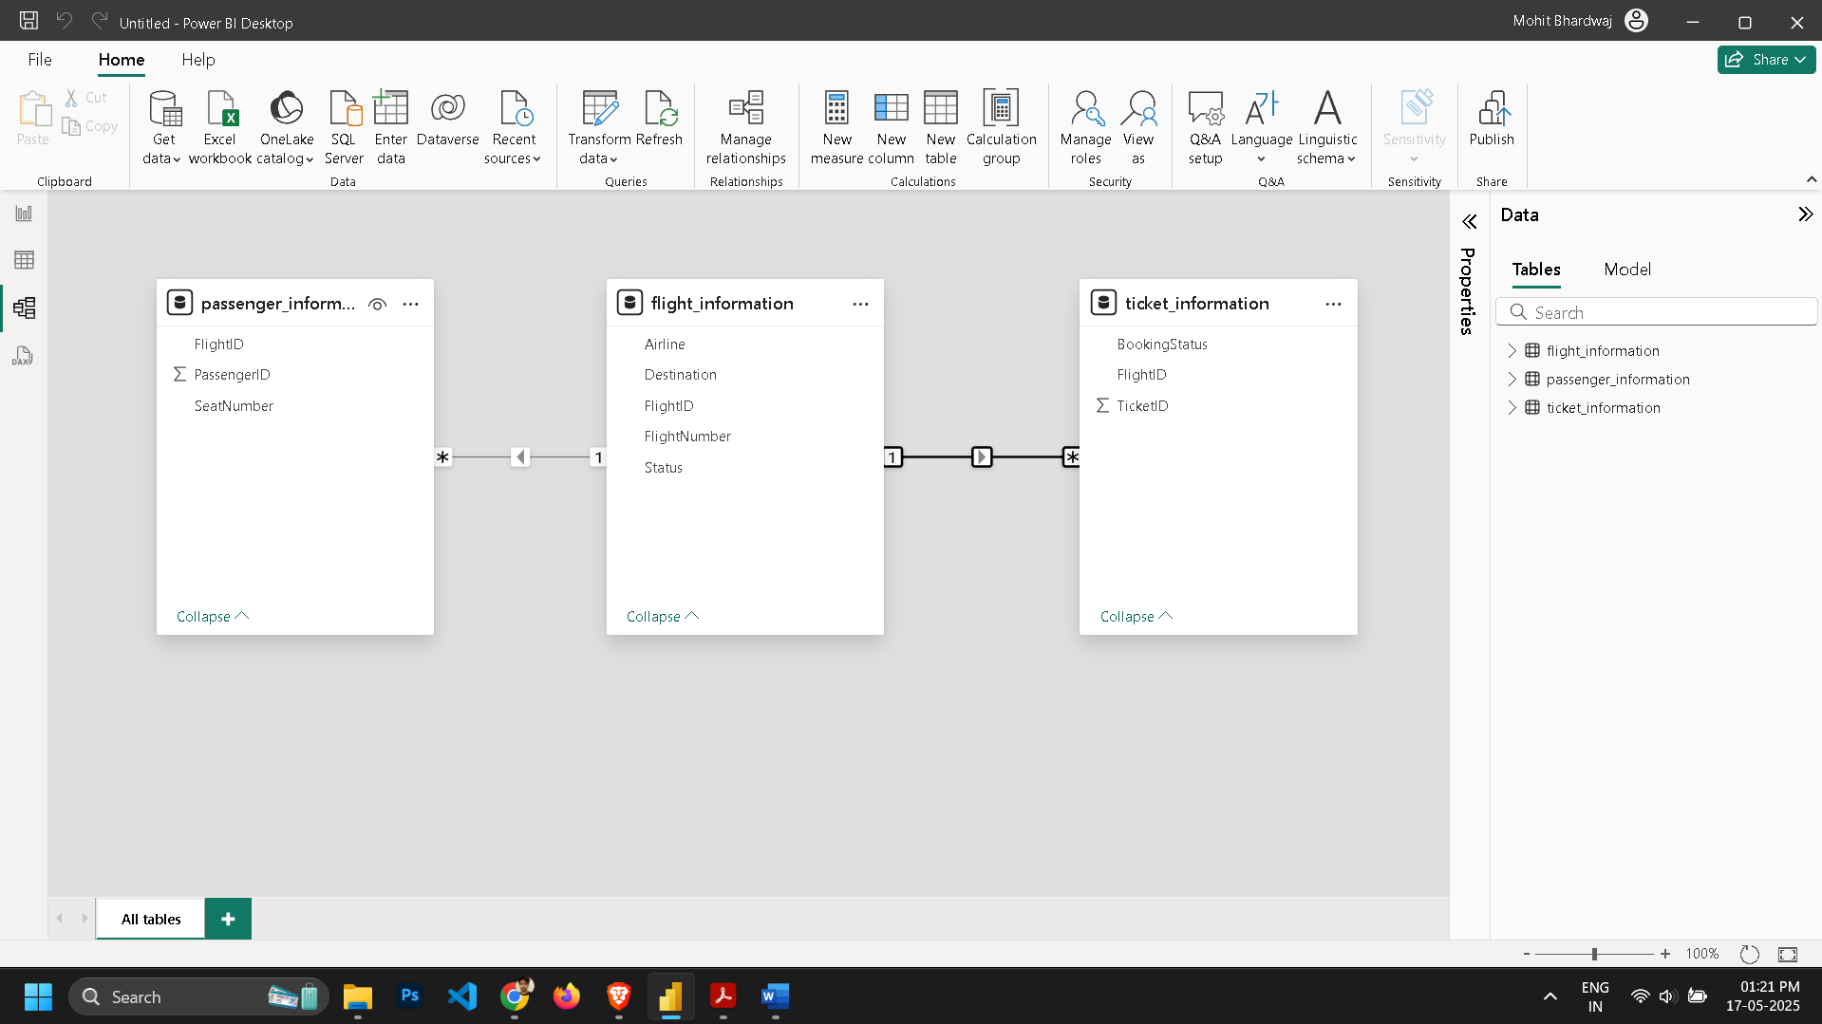

Task 3:- Enhanced Data Insights

● Add a **conditional column** to classify flights as "Best" or "To Be Improved" based on status.

● Use **"Column from Examples"** to extract the flight number from FlightNumber.

● **Deliverables:** Screenshot of the transformed data.

STEP 1): -Click on Transform data that will take us to Power Query editor.

STEP 2): - Then select Add column tab and conditional column.

STEP 3): - Then give conditions according to the Status column requirements on Time = ”Best” and for Delayed and Cancelled = ”To Be Improved”.

STEP 4): - Then again from Add Column Tab then selected “Column from example” after that

“from selection” and give examples of numeric terms from flightNumber column and got our new column that contains only numeric term of FlightNumber.

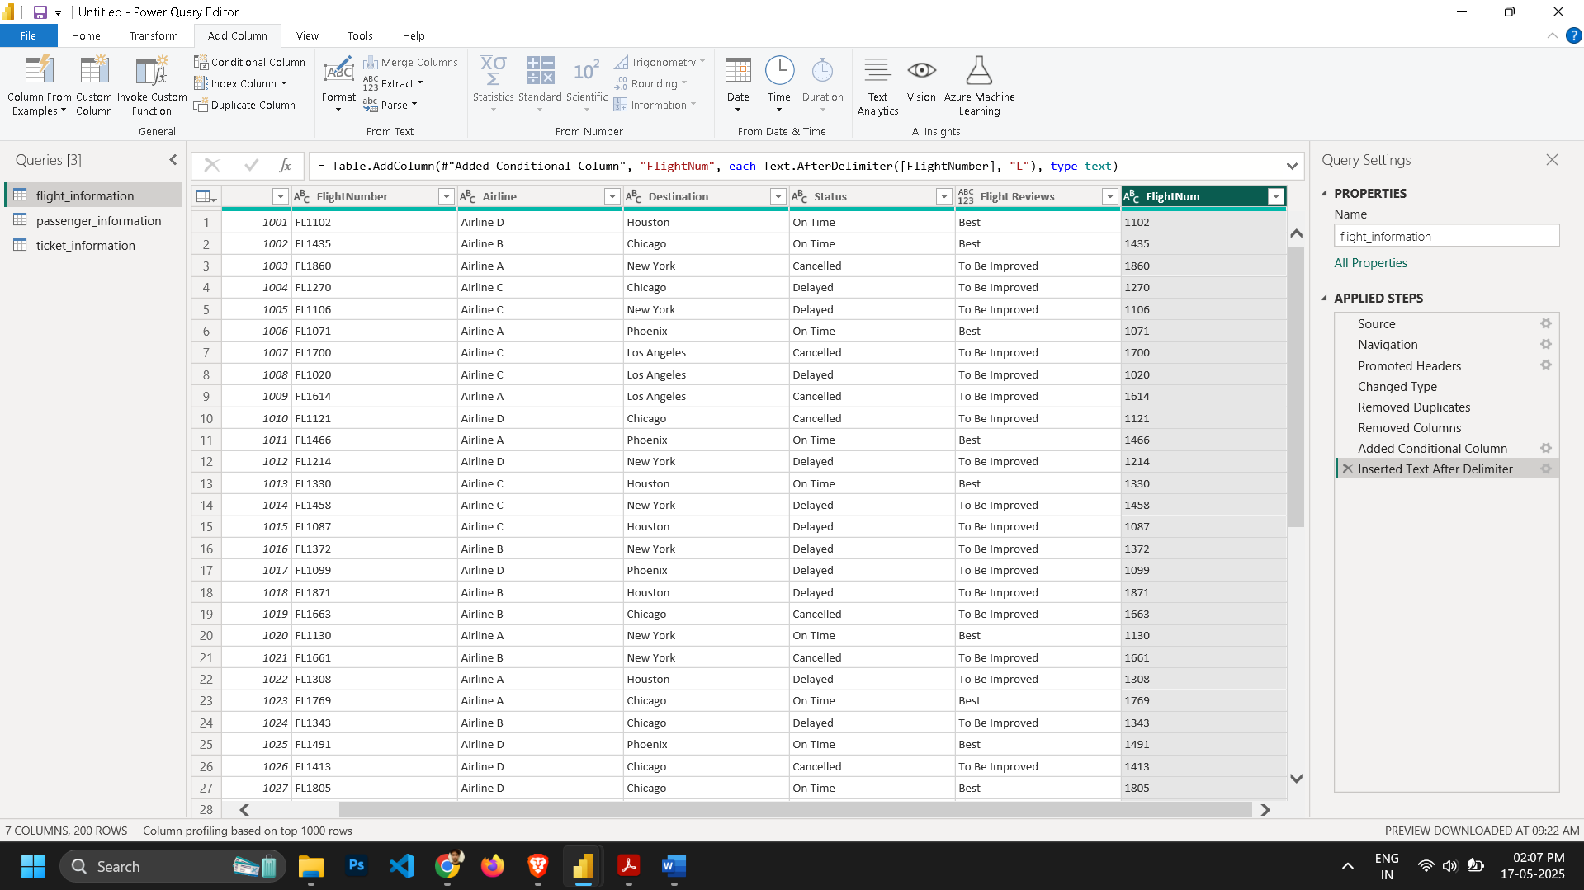

**Task 4:- Calculations Using DAX**

**4.1) Total passengers for a specific flight.**

**Step 1:- Create the DAX Measure**  
In report, go to the **Modeling** tab → **New measure**, and enter something like:

*TotalPassengers = COUNTROWS(Passenger_Information)*

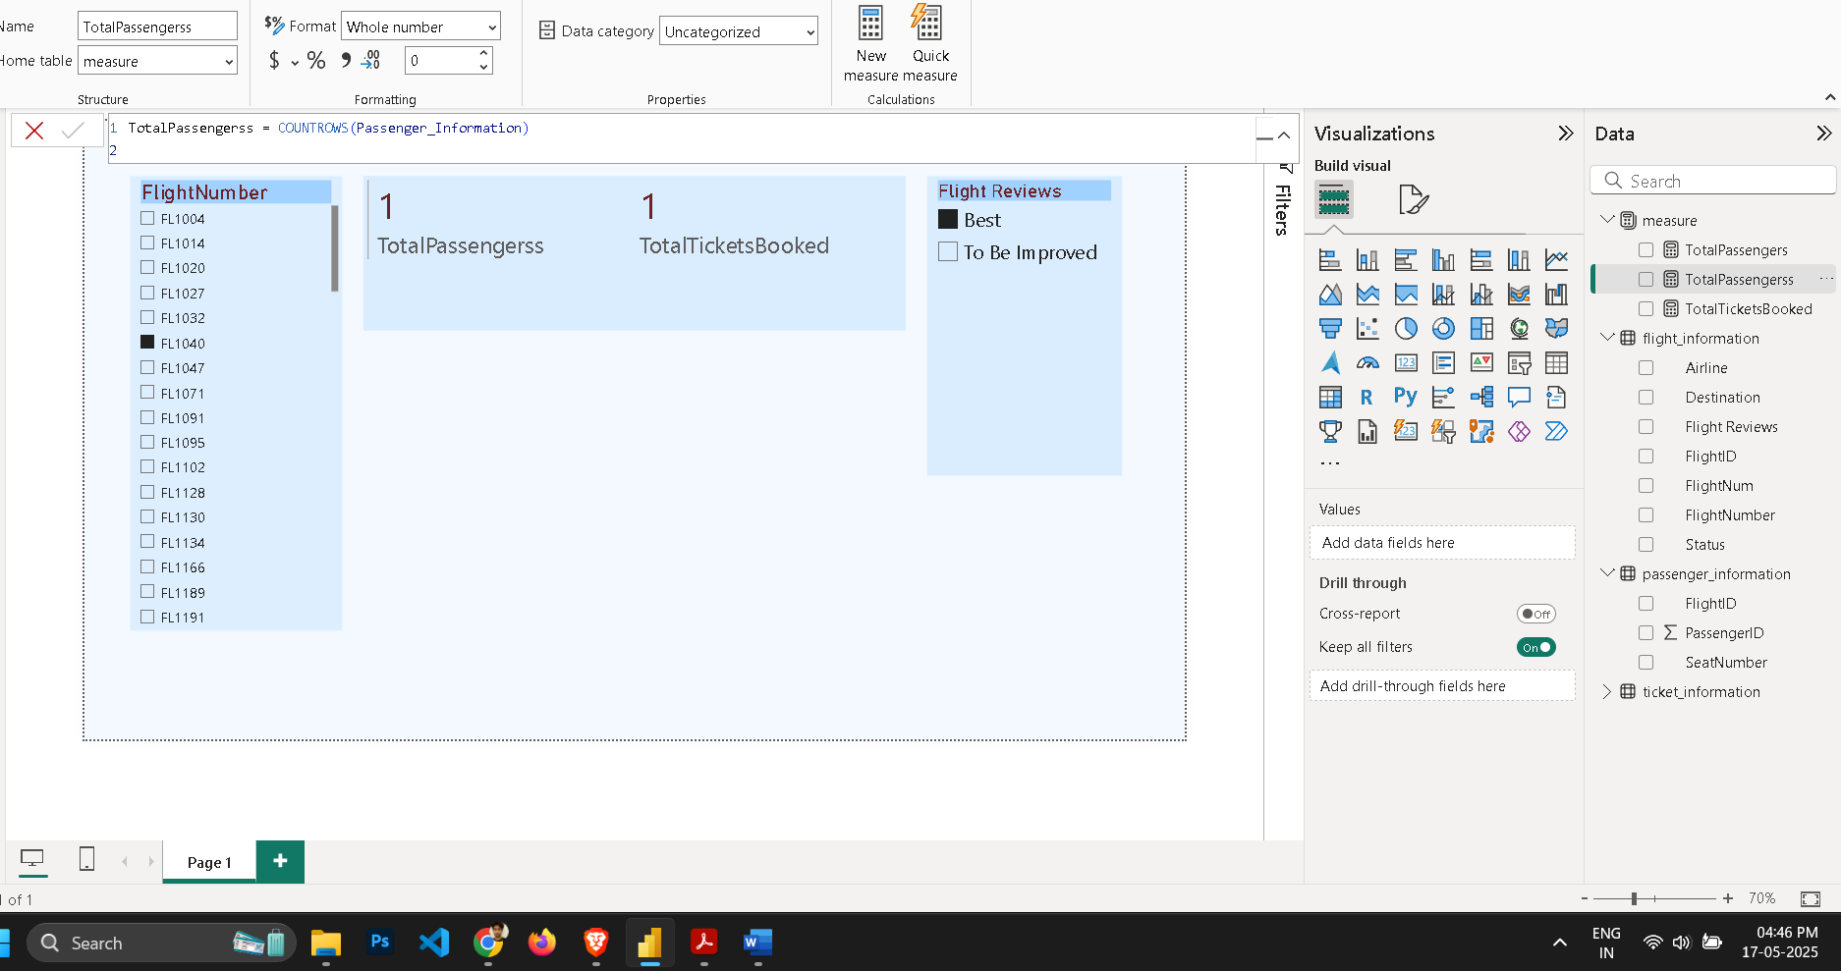

**4.2) Total tickets booked.**

**Step 1:- Create the DAX Measure**  
In report, go to the **Modeling** tab → **New measure**, and enter something like:

*Tickets Booked = CALCULATE(COUNTROWS(Ticket_Information), Ticket_Information[BookingStatus] = "Confirmed")*

**Step 2:- Build the Visual**

* Go to the **Report** view.
* Insert a **Card** visual.
* Drag the **TotalPassengers** measure onto the Card.

**Step 3:- Interactively Change Flight**

* A a **Slicer** to the page: drag **FlightNumber** into a Slicer visual.
* Then the Card will dynamically update to show total passengers for whichever flight you select in that Slicer.

**Step 4:- Add Table and add values Airline, flight number, Destination and tickets booked for detailed view of all ticket booked.**

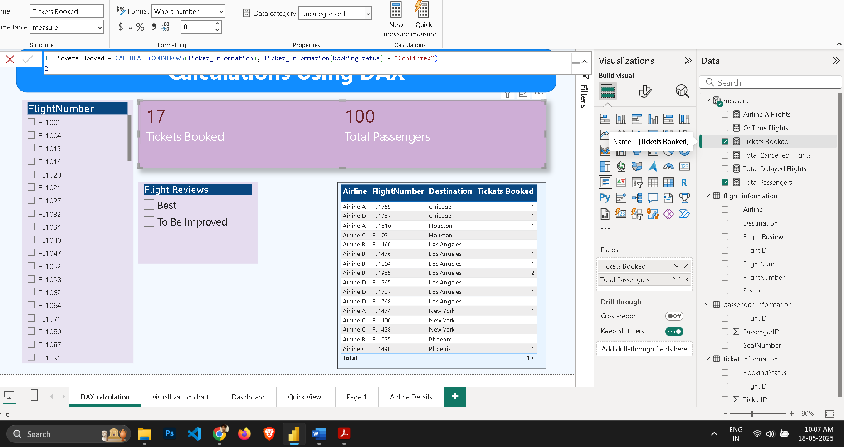

**4.3) Filtered table showing "Best" flights only.**

**In Power BI Report View:**

* Use a **Slicer** with fields from Flight_Reviews that we created earlier.
* Now you can choose this option anytime and see the results in dashboard..
* ***BestFlights = FILTER('Flight_Information', 'Flight_Information'[Flight performance] = "Best")***

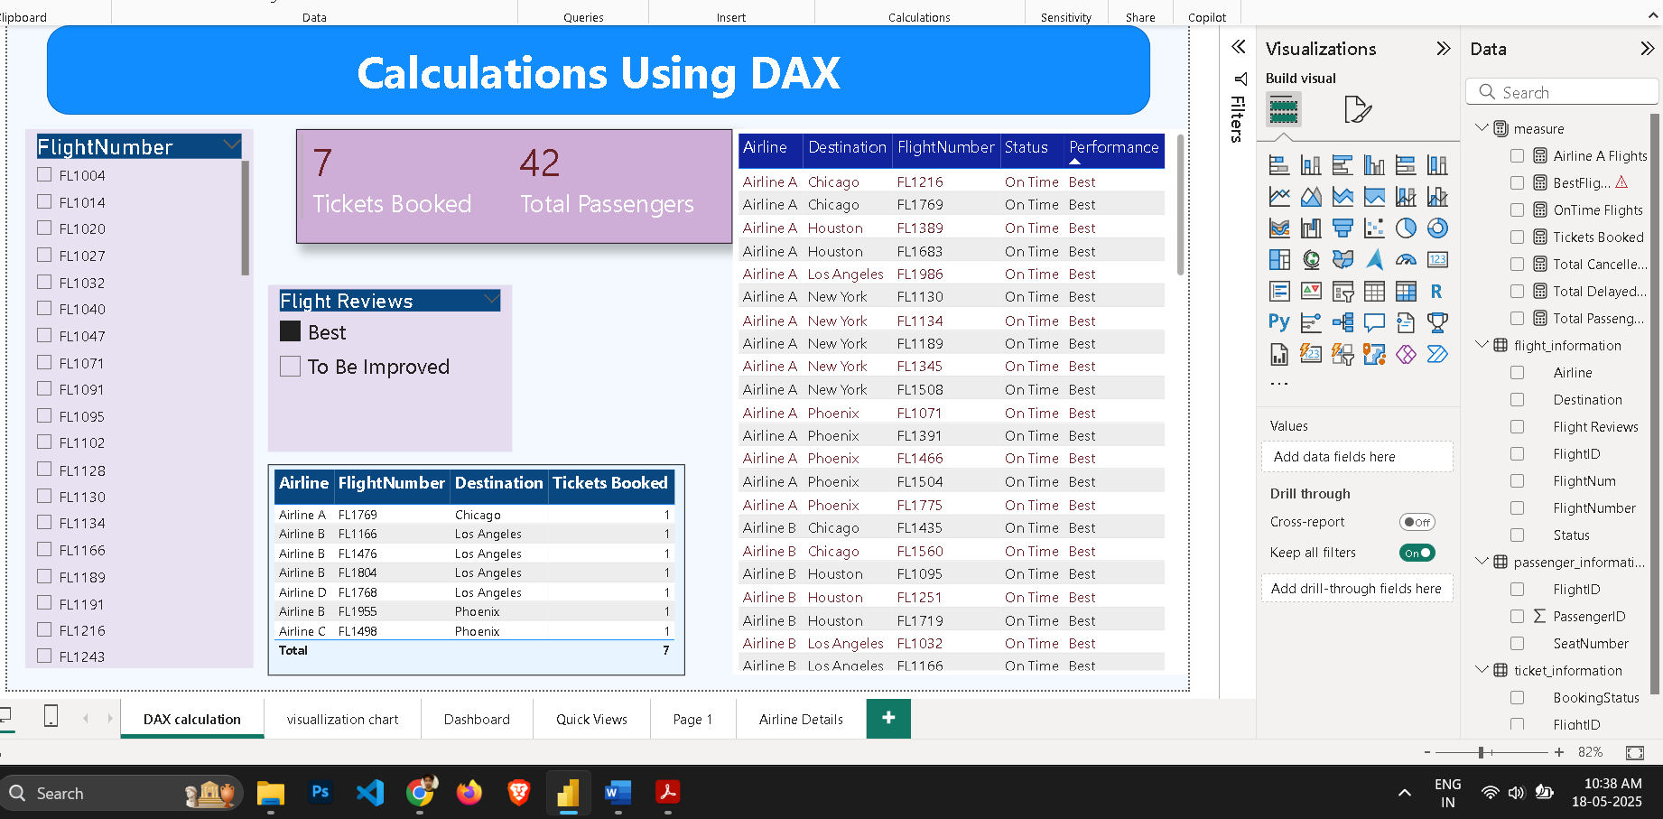

**Task 5:- Visualization and Interactive Features**

**● Visuals for:**

○ Passenger count by airline.

○ Ticket booking statuses.

Use the **Passenger_Information** and **Flight_Information** tables.

Make sure they’re related by FlightID.

Create a **visual** (e.g., bar chart or column chart).

Drag the **Airline** field from Flight_Information to the **Axis**.

Drag **PassengerID** from Passenger_Information to the **Values**, and set it to **Count**.

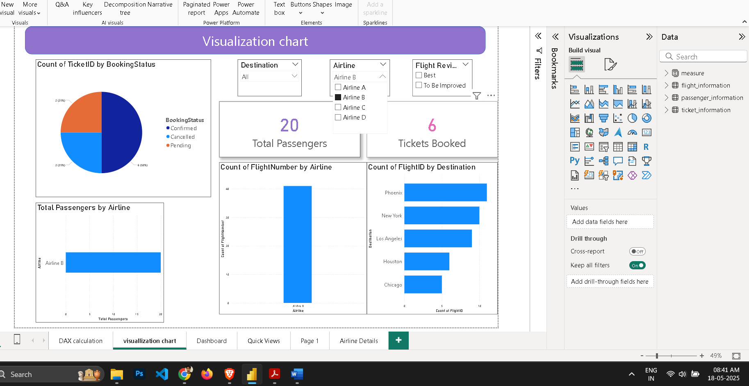

**○ Flights by airline and destination.**

**Insert Slicers:**

* Go to **Report View**.
* From the **Visualizations** pane, click on the **Slicer** visual.
* Drag the Destination field into one slicer.
* Drag the Airline field into another slicer.

**Customize Slicers (Optional):**

* Change orientation to **Horizontal** for button-style selection (via Format → Orientation).
* Use **Drop-down** style if you prefer a cleaner look.

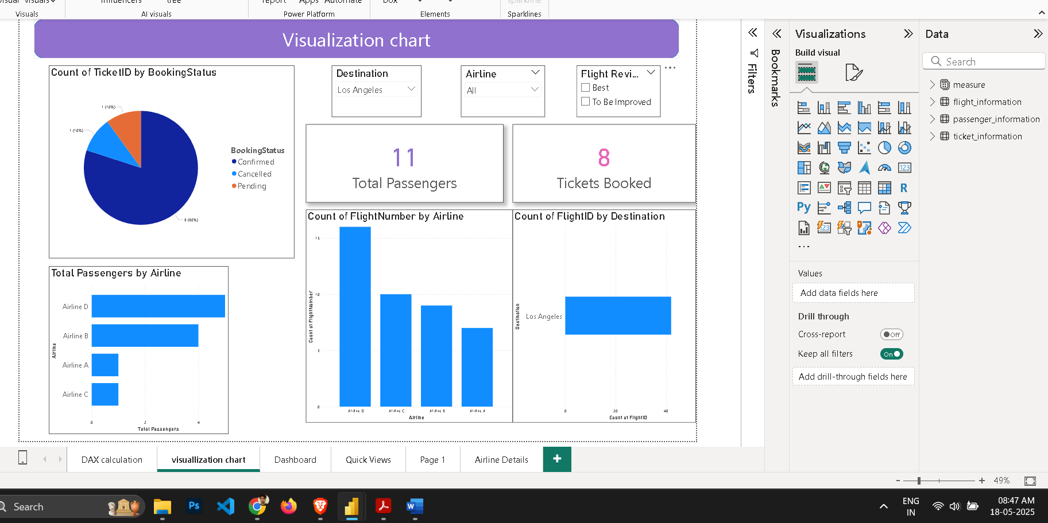

**● Add interactive features for**:

○ Destination and Airline.

**Insert Slicers:**

* + Go to **Report View**.
  + Click on the **Slicer** visual from the Visualizations pane.
  + Drag the Destination field to one slicer.
  + Drag the Airline field to another slicer.

1. **Customize (Optional):**
   * Set slicers to **Dropdown** or **List** from the format pane.
   * Add **search** box (Format → Slicer settings → Show search).
2. **Functionality:**
   * These slicers will let users filter all report visuals by **destination** or **airline** interactively.

### ****2. Airline-Specific Pages****

1. **Duplicate Report Pages:**
   * Right-click a report page and choose **Duplicate Page**.
   * Rename each page (e.g., “Airline A Report”, “Airline B Report”).
2. **Apply Page-Level Filters:**
   * On each page, drag the Airline field into the **Filters on this page** section (Filters pane).
   * Select the specific airline (e.g., only “Airline A”).
3. **Add Navigation Buttons (Optional):**
   * Go to **Insert → Buttons → Blank**.
   * Label the button (e.g., “Go to Airline A”).
   * With the button selected, go to **Format pane → Action**.
     + Turn **Action ON**
     + Set **Type**: Page navigation
     + Choose the target airline-specific page.

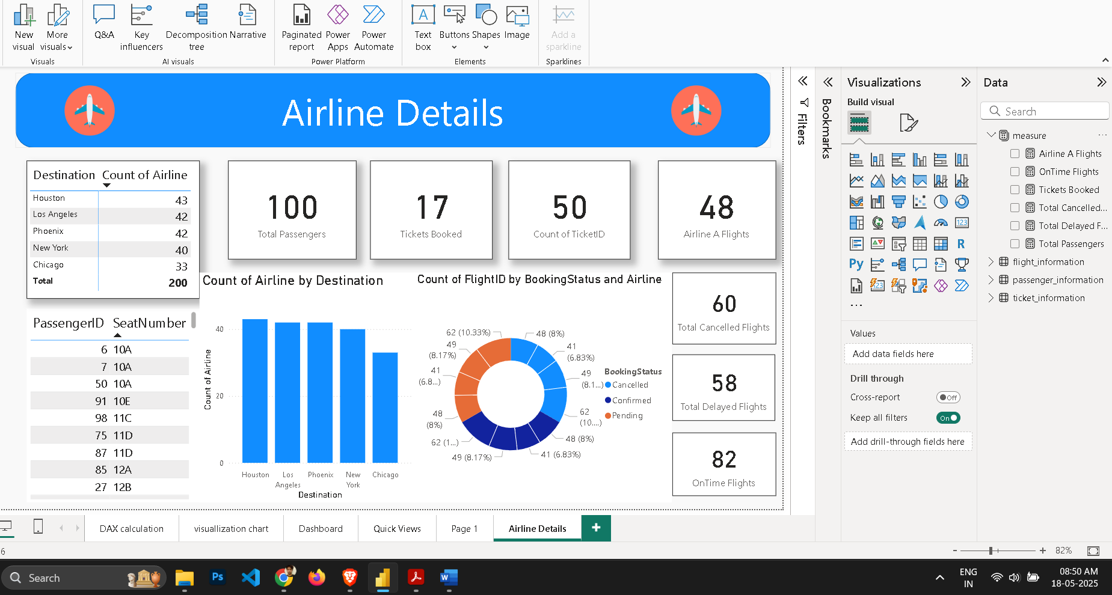

**○ Quick views.**

I used bookmarks for quick view

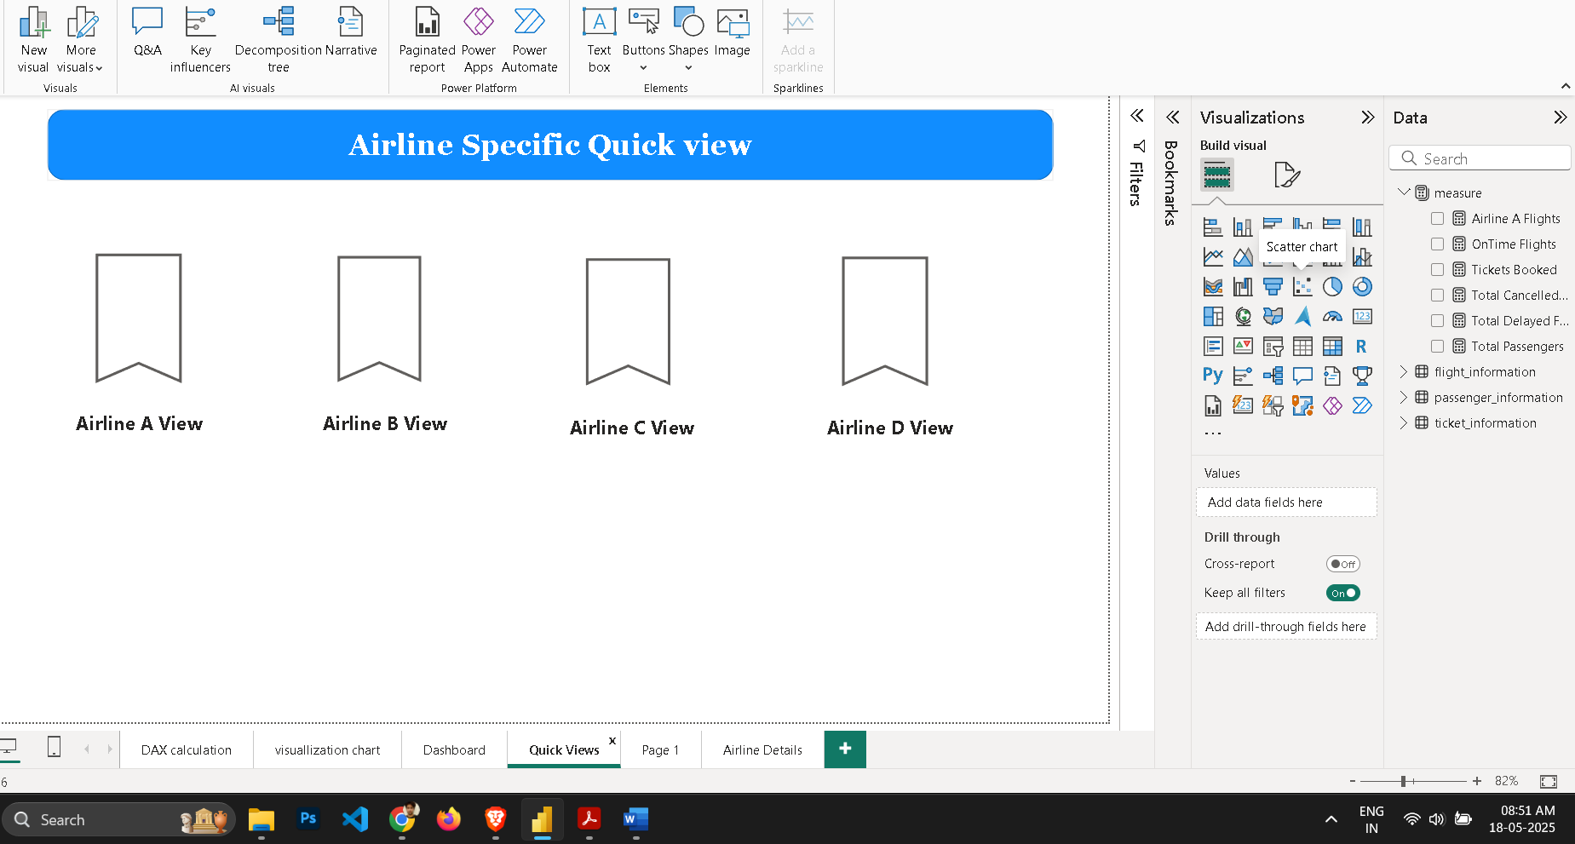

**Task 6:- Final Dashboard and Power BI Service**

● Design a **comprehensive dashboard** with key visuals and insights.

Use **Card visuals** for quick-glance metrics:

* **Total Passanger**
* **Total tickets booked**
* **Flight reviews**

#### **1. Flights by Airline and Destination**

* **Stacked bar chart**
* Axis: Destination
* Legend: Airline
* Values: FlightID (Count)

#### 2. **Passenger Count by Airline**

* **Bar chart** or **donut chart**
* Axis: Airline
* Values: PassengerID (Count)

#### 3. **Ticket Booking Status**

* **Pie or donut chart**
* Legend: BookingStatus
* Values: TicketID (Count)

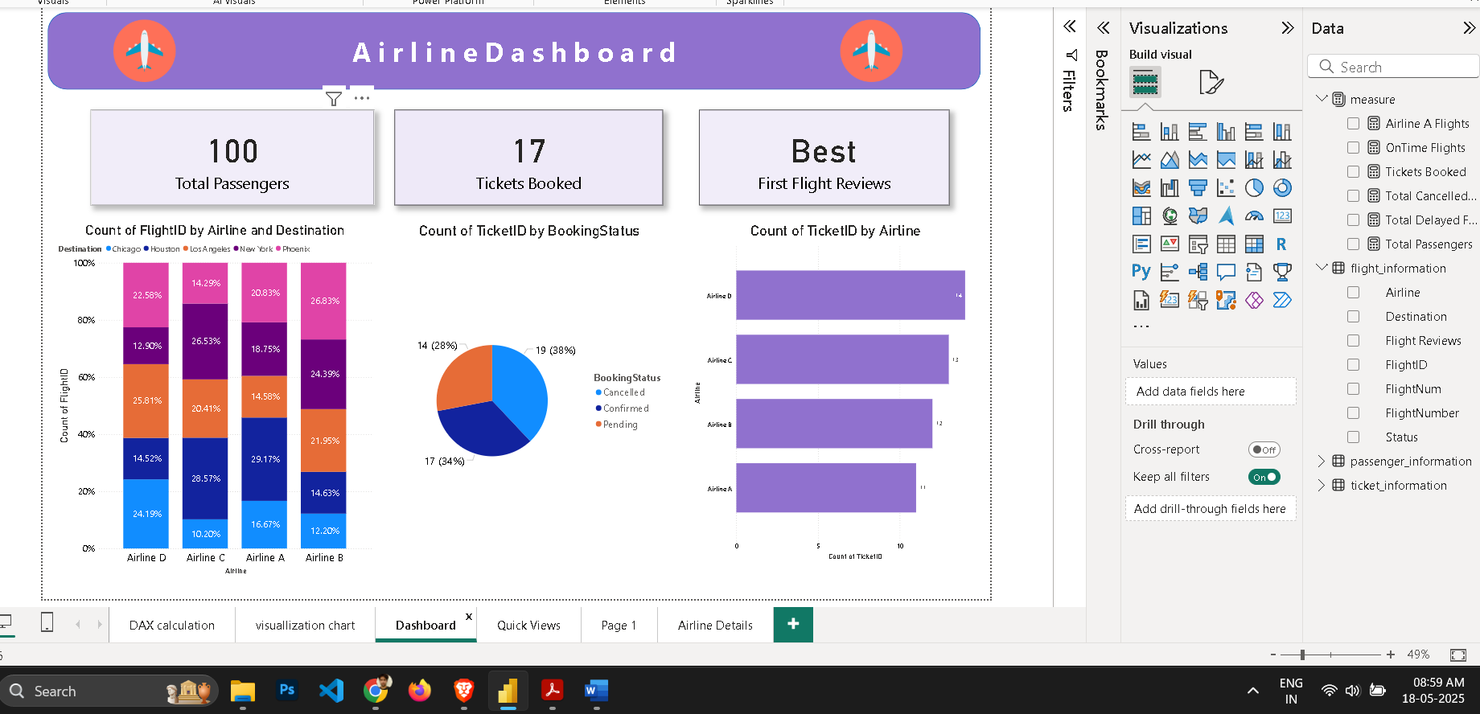

● Configure **Row-Level Security (RLS)** for Airline A data and assign it to a user.

Go to the **Modeling** tab → Click **Manage roles**.

Click **Create** and name the role: AirlineAUser.

Select the Flight_Information table.

In the DAX filter box, enter:

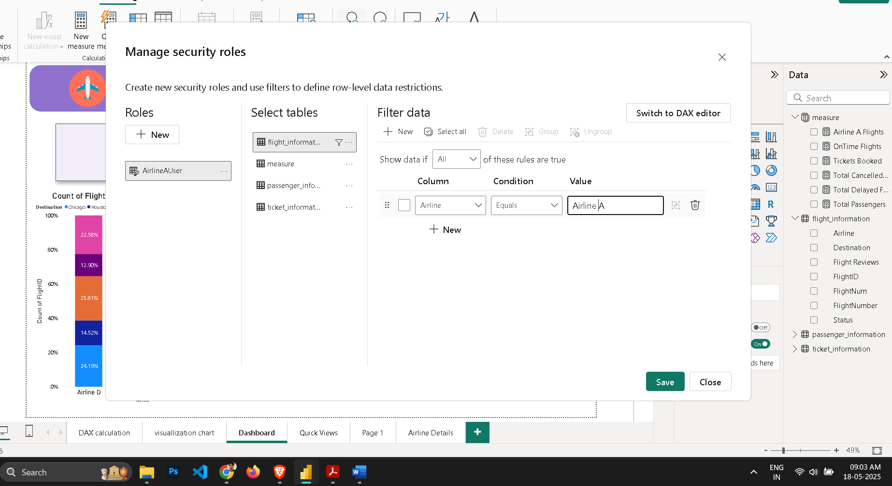

● **Set up a schedule refresh at 5 PM daily.**

**1. Publish Your Report to Power BI Service**

* In **Power BI Desktop**, go to **Home → Publish** → Choose your workspace.

**2. Open the Dataset in Power BI Service**

* Go to Power BI Service.
* In the **left navigation pane**, click on your **workspace**.
* Go to the **Datasets + Dataflows** tab.
* Click the **ellipsis (⋯)** next to your dataset → Select **Settings**.

**3. Set Up Scheduled Refresh**

* Under **Settings → Dataset → Scheduled refresh**:
  + Turn **Keep data updated** to **On**.
  + Under **Scheduled refresh**, click **Add another time**.
  + Set the **Time** to **5:00 PM** and **Time zone** according to your local time.
  + Choose the **Refresh frequency** as **Daily**.

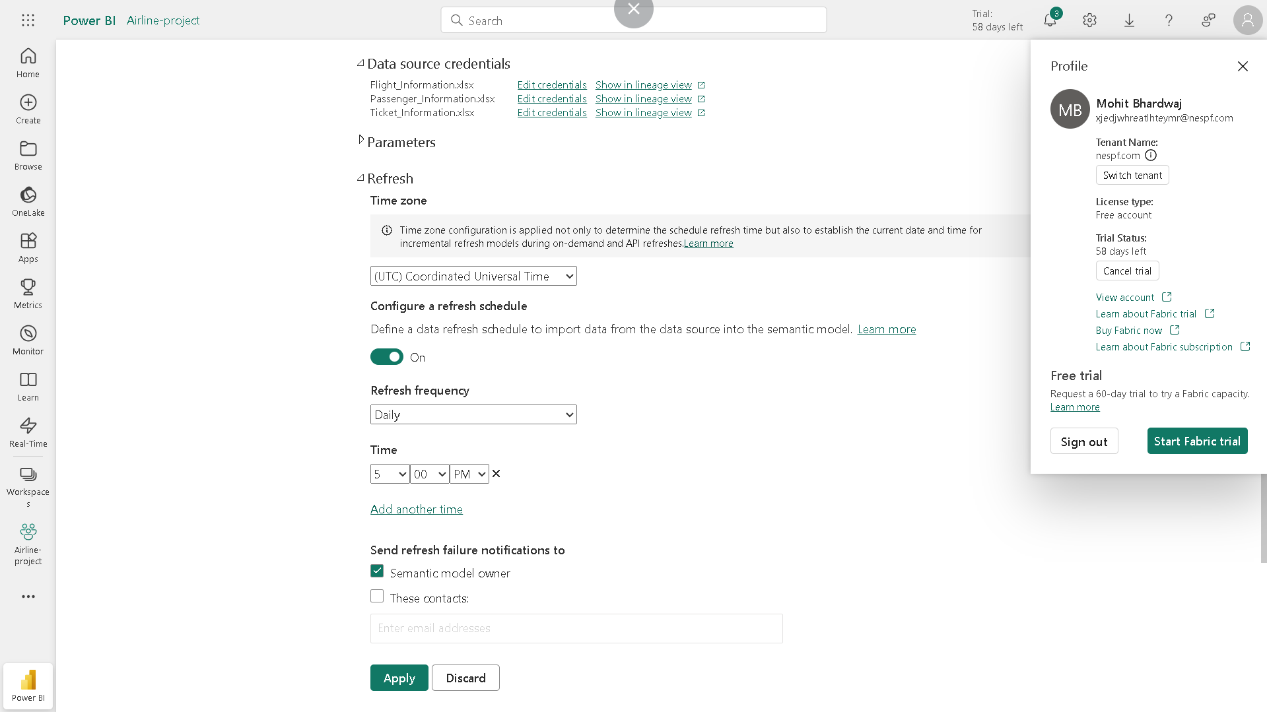

**Video Link**

https://drive.google.com/file/d/1lnL8DwQpzfQUQEsJrVH37uqKipFu_9IA/view?usp=sharing